Reforming governance of international financial regulation; have the G20 done enough?
Hewlett IPD Policy Brief 1
Stephany Griffith-Jones and Kevin Young
Following the worst financial crisis in a generation, the effectiveness of regulation of international finance has been called into question. The global institutions which provide the international standards and rules for the world had also been profoundly undemocratic through their exclusion of developing countries. Following the crisis, and the G20’s reaction to it, significant reforms have taken place to include members from developing countries for the first time in regulatory financial bodies. In what follows, we will examine these reforms and suggest further improvements that would not only improve governance but also serve to make financial regulation more effective for the future.

The critique of past governance
In the years before the current global financial crisis, critique of the composition of global financial regulatory institutions was widespread. In 2002, the United Nations International Conference on Financing for Development produced what was known as the Monterrey Consensus. Among the many points agreed by over fifty Heads of State and two hundred Ministers of Finance, Foreign Affairs, Development and Trade was that the institutions of global financial governance such as the Bank for International Settlements, the Basel Committee on Banking Supervision and the Financial Stability Forum should “…enhance their outreach and consultation with developing countries…” and should “…review their membership to allow for adequate participation of developing countries.” The lack of developing country representation had before and since been critiqued extensively by various academics and NGOs around the world. While the Bank for International Settlements expanded its membership somewhat , institutions such as the Financial Stability Forum (FSF) and the Basel Committee on Banking Supervision (BCBS) continued till recently to exclude any formal participation from developing countries.
Because of the BCBS’s important and authoritative role in setting the international banking standards for the world, it received the lion’s share of the critique. Networks of academics and NGOs also advocated for the reform of the international regulatory institutions more widely. The Committee’s exclusion of developing countries, it was pointed out, distorted and biased the policies designed, making them both ineffective in general and contrary to the interests of the developing world. Even the former Director of the UK Financial Stability Authority, Howard Davies, pointed out the massive discrepancy between financially significant countries and membership on the Basel Committee, and argued that membership should be revised.

Problems the Old System Generated
Deficiencies in the governance of the international financial regulatory institutions generated a number of weaknesses in regulation. While the system of informal information sharing, coordination and communication witnessed some advances, the formal regulatory policies pursued were inadequate. There was a strong set of incentives to promote the financial services sector that competed with the focus to manage risks within it. Especially countries such as the US and UK with extensive and sophisticated financial sectors had an incentive to protect their booming and profitable financial sectors. By under-regulating, systemic risk was allowed to build up. Many of the approaches taken, such as the drive toward quantitative, model-driven, and fundamentally microeconomic approaches to risk reflected a confidence that large banks could measure risk parameters themselves. Several major developing countries were much more skeptical of such approaches, their feasibility and effectiveness, and were fearful of the pro-cyclical dimensions of the regulations developed (i.e. their capacity to exacerbate swings in the economic cycle). If they had had a seat at the BCBS table, their positions may have well improved decision making and policy design.

Recent Reforms: Important Steps in the Right Direction
In the midst of the recent global financial crisis, there have finally been significant expansions of the memberships of the global financial regulatory institutions. These reforms demonstrate that under the right conditions of critique, global financial regulatory institutions can be pressured to reform their memberships. In the context of a major crisis in the core countries, the collaboration of developing countries is needed to resolve the dilemmas of both legitimacy and effectiveness of these institutions. Following the Washington G20 Summit in November 2008 which encouraged the international financial standard setting bodies to review their governance, a number of important institutions expanded their memberships, particularly to developing and emerging countries. Table 1 summarizes these changes in the public regulatory institutions.
Table 1: Recent Membership Reforms since the G20’s Call for Reform
Global Financial Regulatory Body | Previous Membership | Previous Membership From Developing Countries | Time of Expansion | Expansion to Include Members from:
IOSCO | Australia, France, Germany, Hong Kong, Italy, Japan, Mexico, Netherlands, Canada, Spain, Switzerland, UK, USA. | Mexico | February 2009 | Brazil, India, China
BCBS | Belgium, Canada, France, Germany, Italy, Japan, Luxemburg, Netherlands, Spain, Switzerland, Sweden, United Kingdom, United States. | None | March 2009 | Australia, Brazil, China, India, Korea, Mexico, and Russia.
FSF/B | Australia, Canada, France, Germany, Hong Kong, Italy, Japan, Netherlands, Singapore, Switzerland, UK, USA. | None | March 2009 | Argentina, Brazil, China, India, South Korea, Mexico, Russia, Saudi Arabia, Turkey, Spain, European Commission

Early in 2009, the Technical Committee of the International Organization of Securities Commissions Organization (IOSCO), which before had no developing country members aside from Mexico, expanded its membership to include Brazil, India, and China. In March, approaching the deadline set by the G20 for reform, two more expansions occurred. First the Basel Committee on Banking Supervision expanded its membership to include developing countries for the first time, adding Brazil, China, India, South Korea, and Mexico in addition to Australia and Russia. As Figure 1 illustrates below, this closed a remarkably large gap in the degree of representation in the Committee in terms of the countries which supervise the largest 50 banks in the world. However, countries with relatively smaller banks are still not adequately represented , which means that banking regulation may continue to reflect excessively interests of large banks. Shortly thereafter the Financial Stability Forum increased its membership to include the entire G20, plus Spain and the European Commission, and has since been renamed the Financial Stability Board, to reflect that it would be given additional powers. This expansion of membership was also significant, as shown by Figures 2 and 3 below which illustrate that, measured both in terms of world savings and world reserves, the Financial Stability Board now has much more equitable representation than its predecessor.

Figure 1: Percentage of Top 50 Banks (by Market Capitalization) With Regulators Represented in the Basel Committee, March and April 2009
- After BCBS Expansion
Before BCBS Expansion
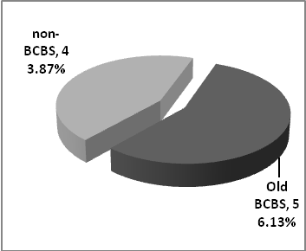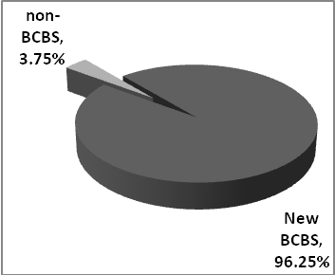

Figure 2: Representativeness of the Financial Stability Forum/Board Measured by World Reserves
- New FSF/B Representation
- Old FSF/B Representation
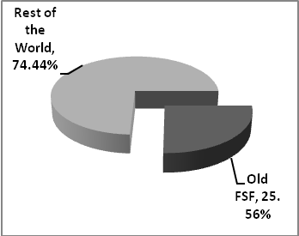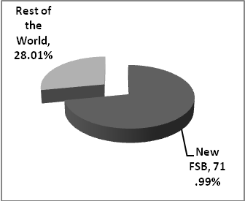
Figure 2: Representativeness of the Financial Stability Forum/Board Measured by World Savings
SaSavings
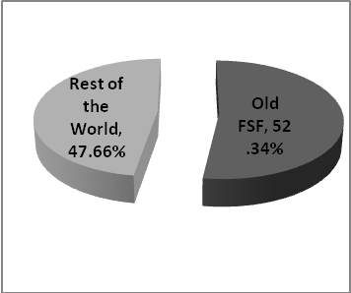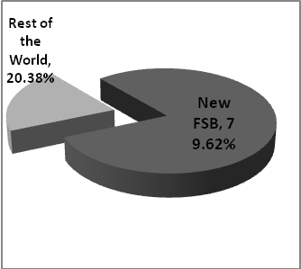
- New FSF/B Representation
- Old FSF Representation

These changes amount to a highly significant expansion of representativeness within the global financial regulatory institutions. For the first time, there is a degree of inclusion of developing and emerging countries in the major decision-making bodies of international financial regulation. Despite the enhancement to representativeness, broader governance issues remain, which we discuss below, and make proposals for further reform.

Proposals for Improving Governance for the Future
It is very welcome that, finally, there has been a significant increase in the participation of developing countries in the governance of international regulatory bodies. This should enhance their legitimacy and representativeness as financial market regulation is finally acknowledged as a global public good which requires global stakeholders to design it. It should also improve their effectiveness, as greater diversity of views – reflecting different experiences – can lead to better outcomes. Most importantly, it will allow the concerns of a diversity of developing countries to be better reflected in international regulatory arrangements. Despite these important steps, a number of other improvements could further enhance the legitimacy and effectiveness of the newly reformed institutions. Five further improvements to the system of global financial regulatory governance should be made:
- Small and medium countries should have some representation in international regulatory bodies. This will firstly ensure that their concerns (e.g. of simpler regulations, as well as of ensuring greater regulatory power of smaller countries over large international banks, via for example host country regulations) are heard. Secondly, since in many of these countries the financial sector is relatively smaller, their financial regulators may be more functionally independent and less at risk of capture by financial interests. Finally, regulation would reflect less exclusively the interests and preferences of large banks, and be more appropriate for regulating smaller banks. Small and medium countries could be represented in international regulatory bodies on a rotating basis, for example, based on three regions (e.g. Asia, Africa and Middle East, as well as Latin America and the Caribbean).

- Attempts could be made to include some forms of representation from non-financial stakeholders, such as unions, and non-financial corporations in international, as well as national, financial regulatory bodies. This would help balance their concerns, needs and perspectives (focused on sustained growth, employment, and long term financial stability) with those of the financial industry which are more unilaterally focused on short-term financial profits.

- Financial regulatory bodies should be made accountable to established forms of political representation. This may include some system of accountability to national parliaments by national regulators and, reflecting international financial interdependence and globalization, should include accountability of international regulatory bodies to multilateral democratic institutions such as the United Nations.

- Given that some developing countries now for the first time have a place in key international regulatory bodies such as the FSF/B and the BCBS, it seems desirable to have a technical secretariat created by developing countries to serve them. This secretariat could prepare or commission studies, provide a forum for debate amongst developing countries and help – where relevant – to define developing country positions on regulatory issues and needs, especially those that require international and/or developed country action. Measures to introduce some international regulation of the carry trade might be an example of this. Developing countries have benefited greatly from the support of the Group of 24 (G-24), which helps them develop their positions in relation to IMF and World Bank matters; a similar body, possibly linked to the G-24, could be created for international regulatory issues, to help develop developing country positions at the FSF/B, BCBS, and other relevant bodies.

- The design and creation of a global financial regulator is one of the main institutional challenges that the international community faces after the global financial crisis. Such an institutional structure would be consistent with the fact that capital and banking markets have very large parts that operate at a global level. For the domain of the market to be consistent with the domain of the regulator, and thus avoid regulatory arbitrage between countries and financial centers, it is a highly desirable option to work toward. By pooling and sharing their power internationally regulators would be increasing their joint control over global financial markets, so those can better serve public policy goals. This would help to make costly financial crises less likely in the future, when financial markets are sure to be even more global, more sophisticated, and even more difficult to contain and regulate than today.

Not only did the BIS expand its central bank membership, in 2006 it also included central bank governors from developing countries (Mexico and China) on its Board of Directors.
See for example Stephany Griffith-Jones and Avinash Persaud, “The Pro-cyclical Impact of Basle II on Emerging Markets and its Political Economy” in Joseph Stiglitz and Jose Antonio Ocampo (Eds.), Capital Market Liberalization and Development (Oxford: Oxford University Press, 2008).
See Howard Davies, “A Review of the Review”, Financial Markets, Institutions & Instruments Vol. 14, No. 5 (December 2005), pp. 247-252.
See David Held and Kevin Young, “Global Financial Governance: Principles for Reform” LSE Ideas: Special Report on the Financial Crisis (London: London School of Economics and Political Science, March 2009) pp. 13-18.
Private international standard-setting bodies such as the International Accounting Standards Board also expanded their membership, committing to an expansion from 14 to 16 members, and guaranteed some greater geographical diversity on its Board.
Values of gross domestic savings are only available for end-2005; they represent gross domestic savings in US dollars. Source: World Bank World Development Indicators.
Values, for total reserves in US dollars, and exclude Gold holdings, from end 2007. Source: World Bank World Development Indicators.

